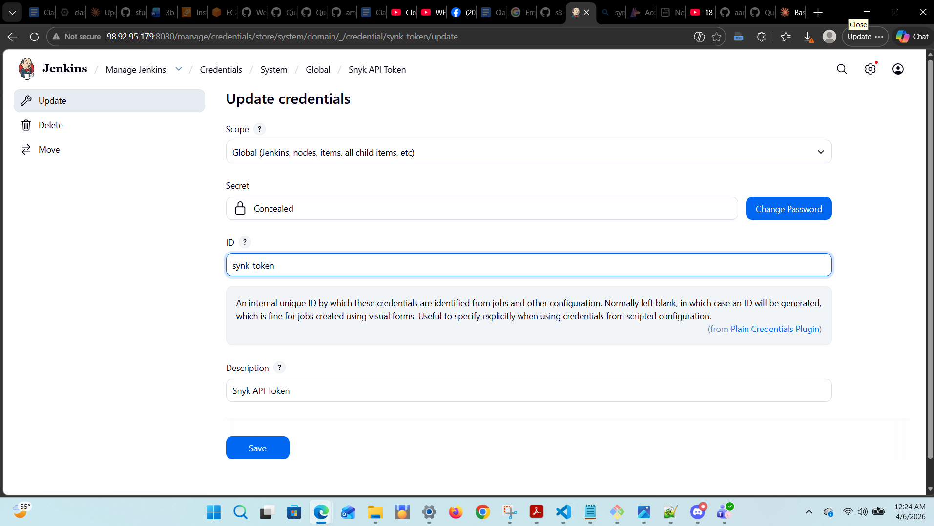

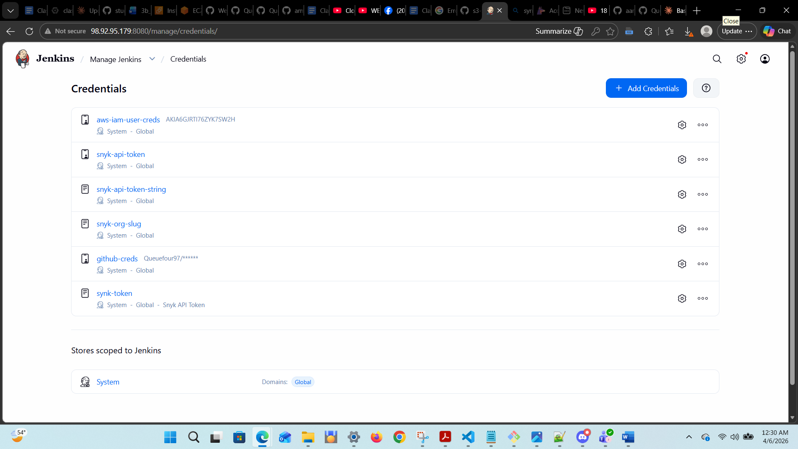

Key: 120b119f-3100-4ff5-845a-f84f387e1cfe

